NO-Age’s Guidelines in sponsoring ageing research-related travels and meetings
NO-Age
Version 1 (24 March 2025)

NO-Age (The Norwegian Centre on Healthy Ageing Network, www.noage100.com) aims to sponsor ageing research-related travels and meetings.

The funding is from NO-Age AS.

In 2025, NO-Age aims to support 4 scientific travels to young scientists and 4 scientific meetings.

- Scientific travels
- Scientific meetings (with NO-Age as a meeting sponsor)
- Appendix I (Application form - for travel)
- Appendix II (Report form - for travel)
- Appendix III (NO-Age logo)
- Appendix IV (Application form – with NO-Age as a meeting sponsor)
- Appendix V (Report form - with NO-Age as a meeting sponsor)

1. Scientific Travels
1.1. Qualifications and application procedure
NO-Age will support 4 scientific travels to young ageing researchers on their attendance of international meetings related to ageing. Some main requirements are
- The candidate should be a master student, PhD student, or a postdoc.
- The meeting to be attended is related to ageing research and clinical matters.
- The candidate should not have their own funding from any sources.
- No more than 15,000 NOK/case, and it will be paid after the event. The amount will be the same as shown in the receipt summary.
- Application procedure: this is an open-ended fund based on the availability of fund; please contact NO-Age coordinator Dr. Evandro Fang-Stavem (e.f.fang@medisin.uio.no) on budget availability before submission. Please fill in the application template (Appendix I) and send to NO-Age (e.f.fang@medisin.uio.no). A decision will be made by the NO-Age Board within 3 weeks for most cases (with exceptions such as public holiday periods etc) after submission.

1.2. Responsibilities of the awardee
- NO-Age should be acknowledged in all related documents (e.g., abstract, poster, oral presentations, meeting reports, etc). It is advised that the NO-Age logo (Appendix III) should be also used in poster and oral presentations.
- Receipts of cost for flight and hotel and local transportation (NO-Age does not support food or drinks), should be included in Appendix II.
- The awardee should submit an activity summary (Appendix II) within 2 weeks after the meeting: the summary should include the activities of the trip and what the awardee learned from the event.
- The awardee should release a news in his/her social media (such as Facebook, Twitter/X, LinkedIn) with one to a few pictures of the events with NO-Age name and / or logo shown up and to tag/cite ‘@NoAge100’ (https://x.com/NoAge100) in Twitter/X, or Facebook (https://www.facebook.com/NOage100/).

2. Scientific meetings (with NO-Age as a meeting sponsor)
2.1. Qualifications and application procedure
NO-Age will support 4 scientific meetings related to ageing. Some main requirements are
- The candidate should be a Norwegian National meeting or an international meeting with the topic on ageing.
- No more than 10,000 NOK/case, and it can be paid before or after the event.
- Application procedure: this is an open-ended fund based on the availability of fund; please contact NO-Age coordinator Dr. Evandro Fang-Stavem (e.f.fang@medisin.uio.no) on budget availability before submission. Please fill in the application template (Appendix IV) and send to NO-Age (e.f.fang@medisin.uio.no). A decision will be made by the NO-Age Board within 3 weeks for most cases (with exceptions such as public holiday periods etc) after submission.

2.2. Responsibilities of the meeting
- NO-Age should be acknowledged in all related documents (e.g., meeting flyers, roll-ups, and electronic media).
- It is advised that the NO-Age logo (Appendix III) should be also used in related media.
- The awardee should submit an activity summary (Appendix V) within 2 weeks after the meeting: the summary should include the related activities and a few pictures of the events with NO-Age name and / or logo shown up.
- The meeting organization (or a key organizer) should release a news on at least one of their social media channels (such as Facebook, Twitter/X, LinkedIn) with one to a few pictures of the events with NO-Age name and / or logo shown up and to tag/cite ‘@NoAge100’ (https://x.com/NoAge100) in Twitter/X, or Facebook (https://www.facebook.com/NOage100/).

Appendix I (Application form - for travel)
- Name (Family name; given name):
- Career stage (e.g., Master student, doctoral student, postdoc):
- Mentor/supervisor:
- Institution:
- Meeting to attend (name, date, and website):

- Proposed total budget (NO-Age only covers the cost of round-trip flight/economy class, lodging, and local transportation; NO-Age does not cover food and drinks; total no more than 15,000 NOK):

- Abstract submitted for this meeting (including title, and abstract, with the later no more than 500 words):

- Please send all in one PDF to Dr. Evandro Fang-Stavem (e.f.fang@medisin.uio.no).

Appendix II (Report form - for travel)
- Name (Family name; given name):
- Career stage (e.g., Master student, doctoral student, postdoc):
- Mentor/supervisor:
- Institution:
- Meeting attended (name, date(s), and website):

- A simple summary of the meeting activities (at least 200 words):

- A picture of the event (with the awardee and the NO-Age logo both shown). NO-Age has the consent from the awardee to use this picture(s) in NO-Age website and NO-Age-related activities. Insert the picture here:

- Have you published a piece of news on social media for this event? Yes - NO (The awardee should release a news in his/her social media (such as Facebook, Twitter/X, LinkedIn) with one to a few pictures of the events with NO-Age name and / or logo shown up and to tag/cite ‘@NoAge100’ (https://x.com/NoAge100) in Twitter/X, or Facebook (https://www.facebook.com/NOage100/).

- The total amount to be reimbursed: xxx NOK

- Insert the Receipts here (NO-Age only covers the cost of round-trip flight/economy class, lodging, and local transportation; NO-Age does not cover food and drinks; total no more than 15,000 NOK):

- Please send all in one PDF to Dr. Evandro Fang-Stavem (e.f.fang@medisin.uio.no).

Appendix III (NO-Age logo)
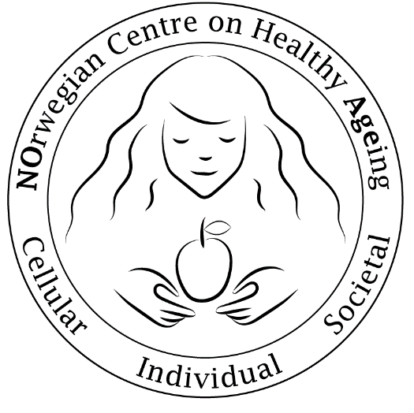
Copy right: NO-Age
Website: https://noage100.com/about-no-age/logo/

Appendix IV (Application form – with NO-Age as a meeting sponsor)
- Name (Family name; given name) of one key organizer:
- Institution:
- Meeting that NO-Age shall sponsor (name, date(s), and website):

- NO-Age to give a one-time 10,000 NOK sponsor

- Why should NO-Age sponsor this event (what benefits that NO-Age can get)?

- How NO-Age, including both its name and its logo, to be presented/displayed in this event?

- Please send all in one PDF to Dr. Evandro Fang-Stavem (e.f.fang@medisin.uio.no).

Appendix V (Report form - with NO-Age as a meeting sponsor)

- Name (Family name; given name) of one key organizer:
- Institution:
- Meeting that NO-Age sponsored (name, date(s), and website):

- A summary on how NO-Age, including both its name and its logo, were presented/displayed in this event (no less than 200 words).

- A picture of the event (with the NO-Age logo shown). NO-Age has the consent from the meeting to use this picture(s) in NO-Age website and NO-Age-related activities. Insert the picture here:

- Evidence that the meeting acknowledged NO-Age on their social media channel(s). The meeting organization (or a key organizer) should release a news on at least one of their social media channels (such as Facebook, Twitter/X, LinkedIn) with one to a few pictures of the events with NO-Age name and / or logo shown up and to tag/cite ‘@NoAge100’ (https://x.com/NoAge100) in Twitter/X, or Facebook (https://www.facebook.com/NOage100/).

- Please send all in one PDF to Dr. Evandro Fang-Stavem (e.f.fang@medisin.uio.no).

